**Start working with Azure SQL Server via SQL Operations Studio**

Contents

Download and install SQL Operations Studio 1

First Login 2

SQL queries. 4

## Download and install SQL Operations Studio

Go to URL: <https://docs.microsoft.com/en-us/sql/sql-operations-studio/download>

Clink on the link highlighted below to download installation that suits your operation system.

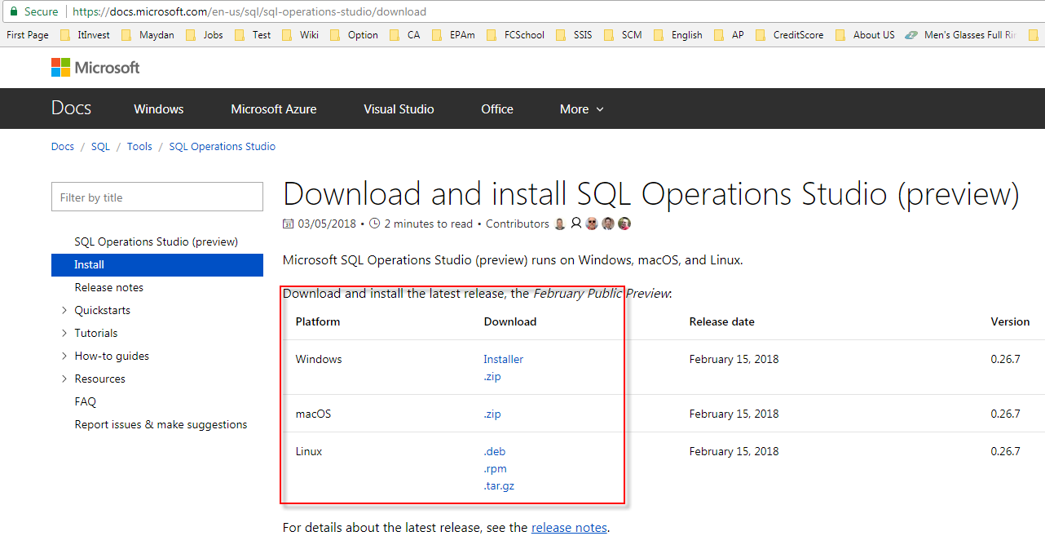

## 

## First Login

When installation finished, go and launch SSMS.

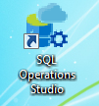

As soon as SQL operation studio started you will be prompted to fill login information.

If not Push the button “New connection”

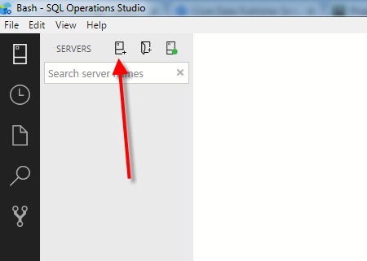

Please fill the fields as depicted at picture below.

Server Name: **homepro.database.windows.net**

Authentication Type: **SQL Login**

Login: **HomeProUser**

Password: **qwerty_123**

Database Name: **main**

Push the button **“Connect”.**

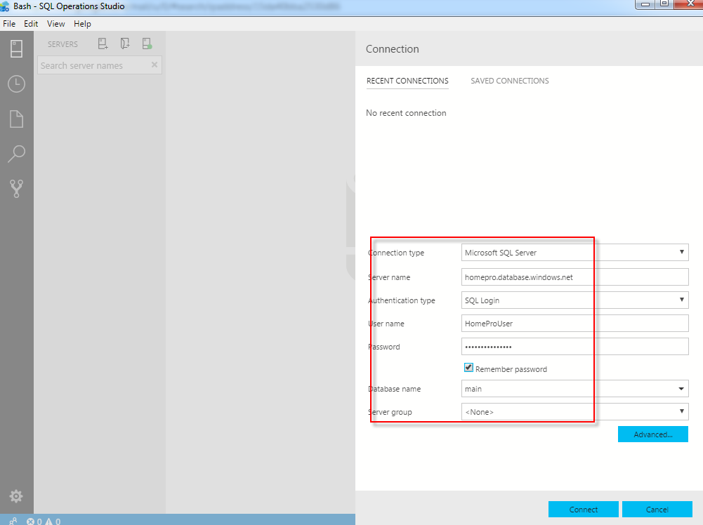

## SQL queries.

Having successful login you must see picture like below. Push the button “New query”.

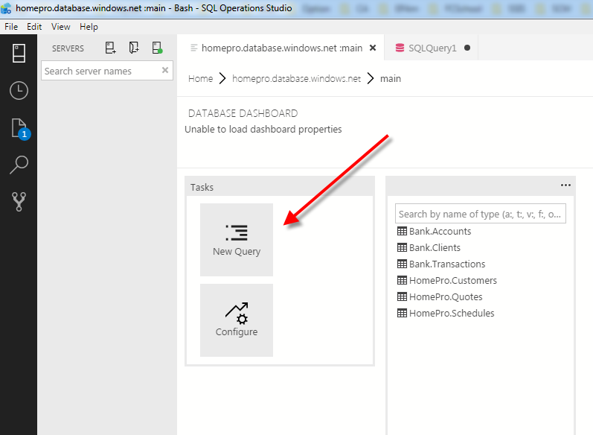

Type SQL query like below and the button “Execute”:

select * from HomePro.Customers

You should see picture like this.

